Township of Robinson, Washington County

Board of Supervisors 2020 Budget
Final Budget

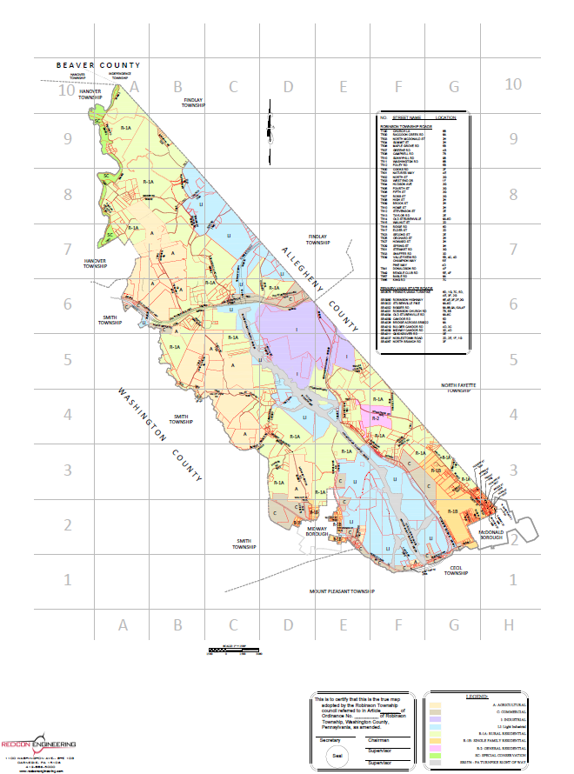

Robinson Township

2020 Budget Message
As Township Manager, I am pleased to provide you with the recommended 2020 Annual Budget for Robinson Township, Washington County. The Budget reflects our commitment to provide quality services and amenities to our residents, while enhancing our goals for growth and preserving our quality of life. All account balances and income/expenses related to specific accounts are as of November 2019.

Budget Approach
Setting long-term priorities for the township is one of the most important responsibilities for the economic growth and stability of the township. With a solid budget set we can move into 2020 knowing that all the township goals can and will be met. The top priority is to preserve and enhance the quality of life Robinson Township residents have come to expect. The 2020 Budget provides the financial resources necessary to meet these expectations. One of the keys to any community is sustainability, and the financial viability to not only make it through the year but into the future. The Supervisors and staff work hard to maintain and achieve this goal.
Millage for Robinson Township 2020 = .001453 mills, or 14.53 cents/one hundred dollars of assessed value
This is Real Estate and Fire Tax combined

What Is A Township
Township governments are distinct from municipal governments because they are established to govern areas without a minimum population concentration. The 2007 Census of Governments counted approximately 3,000 fewer townships than municipalities across only twenty states, including New York, Maine, Illinois, and Kansas. Within these twenty states, there are different kinds of townships: the municipal or the civil, the incorporated or unincorporated, and the school, the judicial, and congressional.
Town government in its classic form is distinguished from township government, as the former is governed by an annual town meeting. Townships, if similar to municipalities, have a municipal form of government. Otherwise, townships are commonly governed by an elected board of three to five part-time trustees and rely almost exclusively on property taxes for revenue. New England, New Jersey, and Pennsylvania townships, for example, enjoy broad authority and perform functions similar to municipalities. Some New England townships govern schools, and Midwestern townships typically perform limited government functions.

Robinson Township

ONGOING PROJECTS
The Southern Beltway
U.S. 22 to Quicksilver Rd. SR 0576, Section 55A1: Adjacent to (East of) Section 55A1-1, is approximately 4 miles in length containing one full interchange and requires nearly 5 million cubic yards of excavation. The project includes 3 mainline bridge structures and one overpass structure. The mainline interchange will be constructed at Beech Hollow Road. Beech Hollow Road and SR 980 will be realigned to create an intersection with Donaldson Road. Candor Road has been reconstructed to connect with the reconstructed “NEW” Beech Hollow Road. Two sections of the “OLD” Beech Hollow are now cul-de-sacs and have been turned over to the Township. The portion coming from Candor Road is now known as Pine Way, and the portion from SR 980 is now known as Champion Way. The third and fourth mainline structures will carry SR 0576 over Little Raccoon Creek and Quicksilver Road. Contractor Trumbull Corporation continues their efforts on Section 55A2 from their field office located on SR 980.
Construction on connector road from the foot of Fort Cherry Road to SR 980 continues, and upon completion will become a Township road, as-yet unnamed. Progress on this road can easily be seen from Cooks Road.

Local Road Repair
Township roads were repaired in multiple phases in 2019.
Phase 1 included completion of surfacing on Raccoon Creek Road in early spring. This improvement was made possible via grant through the Washington County Conservation District’s Dirt and Gravel Road Program. The Township is grateful for the assistance of the County for this project. Source of funding of Phase 1 is Grant.
Phase 2 consisted of base repair and microsurfacing on Taylor, North McDonald, Summit, Orchard, Pine, and Second Street. Other treatments were employed to repair and resurface King, Shaffer, and Meadow. Source of funding Phase 2: Liquid Fuels Account.
Phase 3 is PennDOT recommended improvements to bring Pine Way up to standards, including underdrain replacement, signage, and surfacing. Source of funding: Beech Hollow Turnback Account.
Phase 4 is repair to Fourth Street, which has been compromised by an adjacent slope failure. A temporary repair will be performed pending a more permanent, engineered solution. Funding via Local Shares Grant is being sought for the permanent solution. Source of funding for this repair: Act 13/Gas Well Impact Account.

Approximate cost of road repair funded through the Township in 2019: $317,941.57

Robinson Township
Municipal Building Renovation
The Public Works moved into their new accommodations, making way for Phase 2 in our project. Work on this phase began in 2019 with the development of office spaces and a private conference room in the former Public Works garage. A new entrance for offices is under construction. Relocation of staff offices into this space will make way for the eventual construction of a much larger public meeting room. Work on this building renovation is a combination of Township personnel efforts with assistance from local contractors as needed.
Future front entrance of Township Municipal Offices under construction. Improved parking and entrance ramp are planned for increased ADA compliance and access.
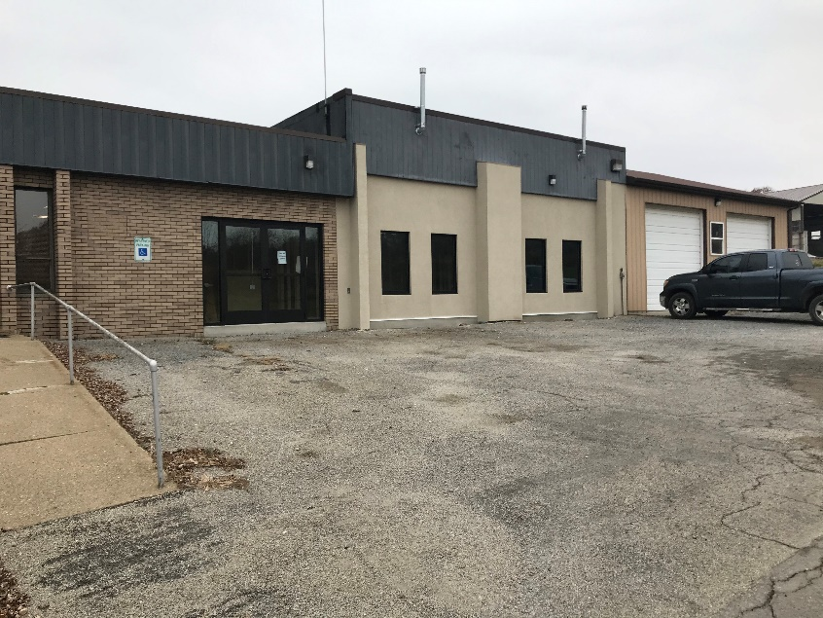

Zoning Ordinance
Changes were made to our Zoning Ordinance in 2019. Administrative language clean-up, zoning changes at the request of property owners, and tables for clearer interpretation were implemented. The IBD District was eliminated and Light Industrial was substituted for all former IBD parcels.

Validity Challenge
The Township continues to defend the zoning changes of 2014 against legal challenges brought by several residents. Costs associated with Validity Challenge, to date: $90,581.32

our emergency personnel

fire service
Robinson Township currently enjoys the protection of both Midway Volunteer Fire Department and McDonald Volunteer Fire Department. In late 2018, the Township entered into a 5-year agreement with each department for continued service.
Contract amount 2020: $25,000/year Midway Fire Department
$25,000/year McDonald Fire Department
Budgeted Workers Comp $19,600/year Both departments
For firefighters

Paid firefighter wages $22,600/year Both departments

Foreign Fire Distribution $11,500/year Both departments

total estimated cost of fire service in 2020: $103,700.00

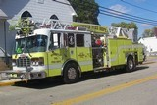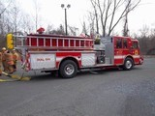

police protection
The McDonald Police Department provides Robinson Township with 24- hour protection, with at least 4 hours per day active patrol. In addition, the department attends Magisterial Court hearings on behalf of the Township and assigns an officer to be present as necessary in meetings held in the Township. Robinson Township recently negotiated a 5-year police contract with Chief Dennis Ahlborn.
Contract amount 2020: $99,368.00
Police car contribution: $10,000.00

total estimated cost of police in 2020: $109,368.00

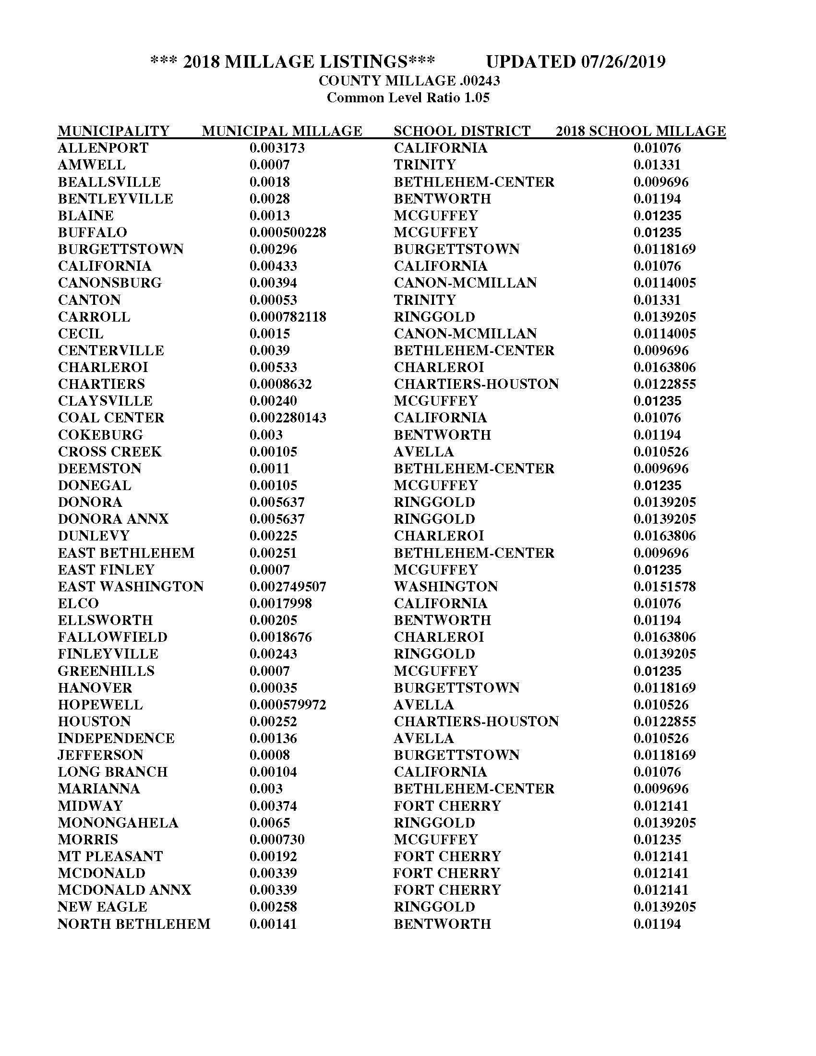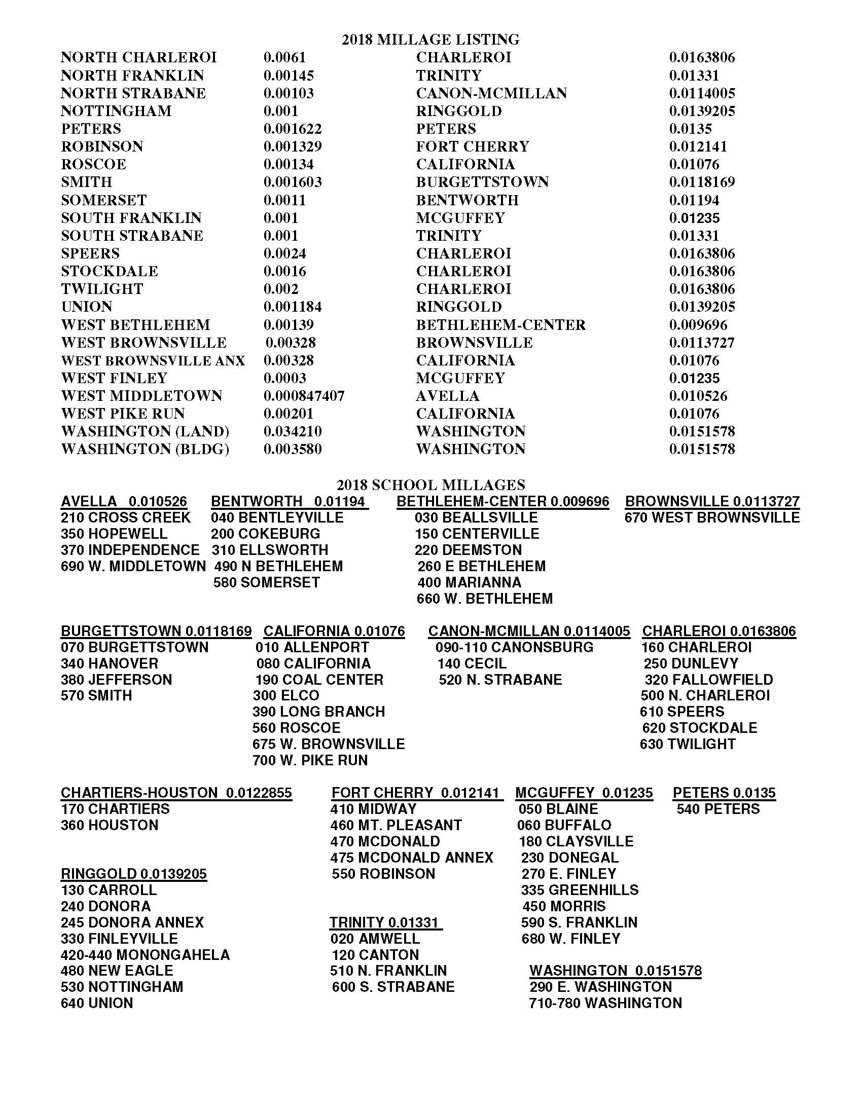
How do I calculate my County taxes if I know the assessed value?
The current Washington County millage is 24.9 (.0249). Example: Assessed value = 10,000 x .0249 = $249.00 at face.

Robinson Township

General Fund
In public sector accounting, the primary or catch-all fund of a government, government agency, or nonprofit entity is the General Fund. It is similar to a firm's general ledger account, and records all assets and liabilities of the entity that are not assigned to a special purpose fund. It provides the resources necessary to sustain the day-to-day activities and thus pays for all administrative and operating expenses. When governments or administrators talk about 'balancing the budget' they typically mean balancing the budget for their general fund.
The primary source of revenue into the General Fund is real estate and earned income tax collection. Other revenues include the various application fees for activities within the township.
The many costs of keeping the township running are paid from this account: employee payroll, insurance, utilities, fuel, repairs to equipment, fees payable to township solicitor and engineer and others.
Balance in the General Fund Account is: $25,336.14
Fire Tax
The Fire Tax Account is dedicated to the support of the two volunteer fire departments that service us: Midway V.F.D. and McDonald V.F.D. Increasingly, our tax is proving insufficient to offset rising costs affiliated with this service. A small increase to the Fire Tax was approved at the November 12, 2018 meeting.
FIRE TAX COLLECTION IN 2019: $46,953.71
Cost of contracts and worker’s compensation for Fire Departments in 2020: $88,537.36
Fire Hydrant Tax
The Fire Hydrant Tax was implemented in 2015 and is assessed on properties within 780 feet of a hydrant. The revenues from this account are used to pay Pennsylvania American Water for water service to the hydrants.
FIRE HYDRANT TAX COLLECTION IN 2019: $7,956.00
Street Light Tax
The Street Light Tax is exclusively devoted to paying electrical costs from West Penn Power for service to the lights.
STREET LIGHT TAX COLLECTION IN 2019: $6,289.15

Robinson Township

Liquid Fuel
The Municipal Liquid Fuels Program funds a range of projects to support construction, reconstruction, maintenance and repair of public roads or streets. Funds are only available to municipalities who submit annual reports. The amount of a municipality's allocation is based on its population and miles of roads on their approved Liquid Fuels Inventory. To be placed on the system a road must have minimum of 33' right-of-way in a township and 16' in a borough. The "cart way" (drivable surface) must be a minimum width of 16', and the road must be a minimum of 250' in length. If the road is a dead end, it must have a cul-de-sac (turnaround) at the end with a minimum 40' radius. To continue to receive Liquid Fuels funds, a road must be maintained in such a condition that it can be driven safely at 15 mph.
MUNICIPALITIES may use Liquid Fuels funds for the following:
• Maintenance, repair, construction or reconstruction of public roads, streets, alleys, courts, and ways, including bridges, culverts and drainage structures, for which municipalities are legally responsible
• Road materials for the maintenance, repair, construction or reconstruction of public roads, streets, alleys, courts, and ways for which they are legally responsible
• Payment of approved Pennsylvania Infrastructure Bank (PIB) Loans including financing expenses with project approval
• Purchase, maintenance and repair of traffic control devices such as signs and signal devices
• Payment of road employee wages for working on the municipality’s roads, structures, and road equipment
• Construction of approved salt storage facilities used only to store salt
• Purchase of safety equipment and protective clothing
• Maintenance, repair, construction, or reconstruction of ADA curbs ramps or curb cuts for access by individuals with disabilities
• 20 percent limit on new equipment purchases and year-to-year carryover ability

Balance in the Liquid Fuel Account is: $7,367.02
Estimated Liquid Fuels allocation for 2020: $106,219.22
ESTIMATED TURNBACK ALLOCATION FOR 2020: $12,080.00

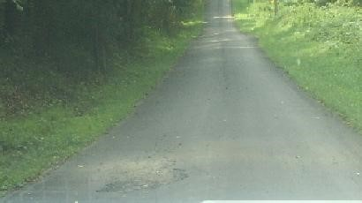

Robinson Township

Local Share
As required under Act 71 (the Gaming Act), DCED has developed program guidelines for Local Share Account funds in Washington County. Uses for LSA funds may be used for economic development, job training, community improvement and public interest projects in Robinson Township. In 2019, the funds were used for offsetting emergency personnel costs and legal fees.

Balance in the Local Share Account is: $2,582.96

Capital Reserve
A capital reserve is a type of account on a municipality's or company's balance sheet that is reserved for long-term capital investment projects or other large and anticipated expenses that will be incurred in the future. Primary uses of this account in 2019 were to purchase a John Deere Loader, with a very lucrative trade-in given for our old Loader, and a new John Deere Tiger mower. The old John Deere Tiger mower was sold to Bullskin Township, Fayette County for $18,000.00, with proceeds being deposited into the Capital Reserve account. Other uses for this account are expenditures related to Phase 2 of our municipal complex renovation, turning the former public works garage into offices for staff and a conference room. Work is being performed by Township personnel and local contractors as needed.
BALANCE IN THE CAPITAL RESERVE ACCOUNT IS: $382,618.93
Beech Hollow Turn Back
On April 27, 2016 Robinson Township entered into an agreement with the Commonwealth of Pennsylvania, acting through the Department of Transportation to transfer jurisdiction of the State Route 4010, Beech Hollow Road back to Robinson Township. The legal process for Township takeover of the sections of “old” Beech Hollow are nearly complete. This account is set up to do all maintance on the road now as well as the future reconfiguration of the road. In late fall 2019, improvement was contracted for section of “old” Beech Hollow at a cost of $93,570.87. Funds related to the turnback were invested with PLGIT in 2019, a municipal investment pool which pays a very competitive interest rate, while remaining liquid and accessible.
Received on June 1, 2016: $529,911.72
Balance in the Beech Hollow Turn Back Account is: $434,270.31

Robinson Township

Gas Well Impact Fund
Act 13 of 2012 (Impact Fee) was signed into law by Governor Corbett on Feb. 14, 2012. Act 13/Impact Fee amends Title 58 (Oil and Gas) of the Pennsylvania Consolidated Statutes (Act 13 of 2012).
Act 13/Impact Fee provides for the imposition of an unconventional gas well fee (also called an impact fee), and the distribution of those funds to local and state governments. Act 13/Impact Fee also contains provisions regarding how the impact fee may be spent.
Unconventional Gas Well Fund Usage:
- Construction, reconstruction, maintenance and repair of roadways, bridges and public infrastructure.
- Water, storm water and sewer systems, including construction, reconstruction, maintenance and repair.
- Emergency preparedness and public safety, including law enforcement and fire services, hazardous material response, 911, equipment acquisition and other services.
- Environmental programs, including trails, parks and recreation, open space, flood plain management, conservation districts and agricultural preservation.
- Preservation and reclamation of surface and subsurface waters and water supplies.
- Tax reductions, including homestead exclusions.
- Projects to increase the availability of safe and affordable housing to residents.
- Records management, geographic information systems and information technology.
- The delivery of social services.
- Judicial services.
- Deposit into the municipality’s capital reserve fund if the funds are used solely for a purpose set forth in Act 13 of 2012.
- Career and technical centers for training of workers in the oil and gas industry.
- Local or regional planning initiatives under the act of July 31, 1968 (P.L. 805, No. 247), known as the Pennsylvania Municipalities Planning Code.
This account is invaluable for minimizing impact to the General Fund and offsetting costs as allowable, above. Our primary use in 2019 was paying costs under use 3: emergency personnel.
Balance in the act 13 gas well Account is: $306,635.50

